**Chapter 3**

**Derivatives**

**3.7 Derivatives of Inverse Functions**

**Section Exercises**

**For the following exercises, use the graph of to**

1. **sketch the graph of  and**
2. **use part a. to estimate **

261.

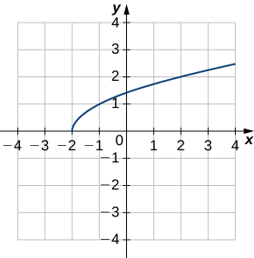

Answer: a.

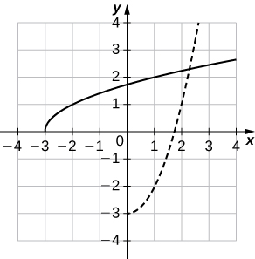

b. 

263.

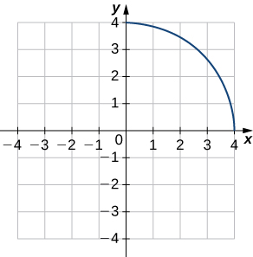

Answer: a.

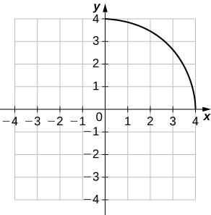

b.

**For the following exercises, use the functions  to find**

1. ** at and**
2. 
3. **Then use part b. to find  at **

265. 

Answer: a. 6, b. , c. 

267. 

Answer: a. , b.  c. 

**For each of the following functions, find **

269. 

Answer: 

271. 

Answer: 

273. 

Answer:

**For each of the given functions **

1. **find the slope of the tangent line to its inverse function at the indicated point  and**
2. **find the equation of the tangent line to the graph of at the indicated point.**

275. 

Answer: a. , b. 

277. 

Answer: a.  b. 

**For the following exercises, find  for the given function.**

279. 

Answer: 

281. 

Answer: 

283. 

Answer: 

285. 

Answer: 

287. 

Answer: 

**For the following exercises, use the given values to find **

289. 

Answer: 

291. 

Answer: 

293. 

Answer: 

295. **[T]** The position of a moving hockey puck after  seconds is  where  is in meters.

1. Find the velocity of the hockey puck at any time .
2. Find the acceleration of the puck at any time .
3. Evaluate a. and b. for and  seconds.
4. What conclusion can be drawn from the results in c.?

Answer: a.  b.  c. d. The hockey puck is decelerating/slowing down at 2, 4, and 6 seconds.

297. **[T]** A pole stands 75 feet tall. An angle  is formed when wires of various lengths of  feet are attached from the ground to the top of the pole, as shown in the following figure. Find the rate of change of the angle  when a wire of length 90 feet is attached.

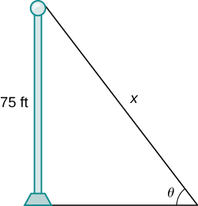

Answer:  radians per foot

299. **[T]** A local movie theater with a 30-foot-high screen that is 10 feet above a person’s eye level when seated has a viewing angle  (in radians) given by 

where  is the distance in feet away from the movie screen that the person is sitting, as shown in the following figure.

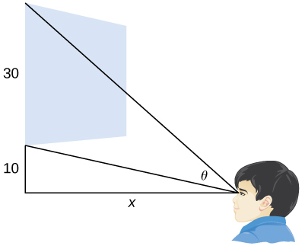

1. Find .
2. Evaluate for , and 20.
3. Interpret the results in b.
4. Evaluate for  and 40
5. Interpret the results in d. At what distance should the person stand to maximize his or her viewing angle?

Answer: a. b.  c. As a person moves farther away from the screen, the viewing angle is increasing, which implies that as he or she moves farther away, his or her screen vision is widening. d. e. As the person moves beyond 20 feet from the screen, the viewing angle is decreasing. The optimal distance the person should stand for maximizing the viewing angle is 20 feet.

This file is copyright 2016, Rice University. All Rights Reserved.